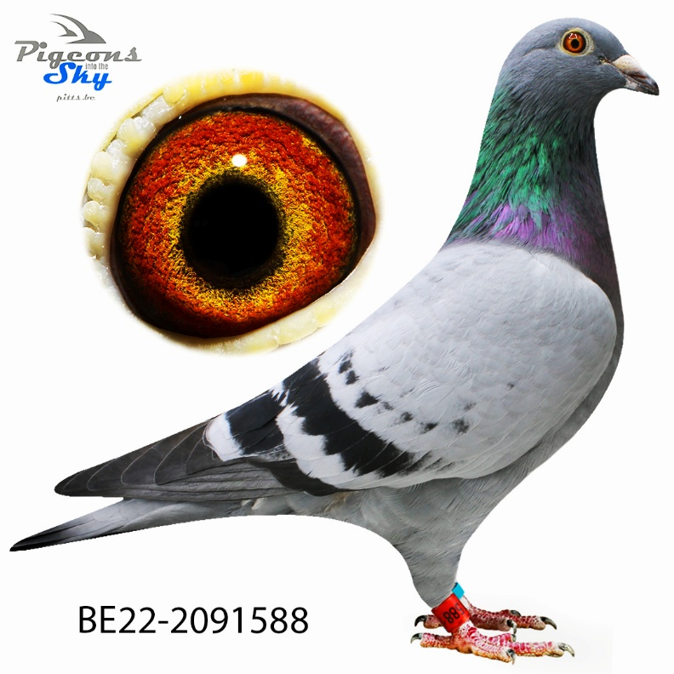

“Lotte”
  - 24th Best pigeon GMD KBDB 3 prizes PIPA-Rankings 2023
  - 33th Best pigeon GMD KBDB 7 prizes PIPA-Rankings 2023
  - 3 times top 10 national zone B1
  - Vierzon 3/ 1081
  - Vierzon 8/ 1370
  - Chateauroux 10/ 1588
  - Noyon 8/ 188
  - Chateauroux 7/ 390
  - Argenton 167/3135

